850 | Height
1300 | Width
#FCFCFC | Page Background
#6365DD | Filter Panel and border
#FFFFFF | Cards
#E6E6E6 | Cards Shadow
#094780  #12239E  #50005C  #893395 | Charts Colors
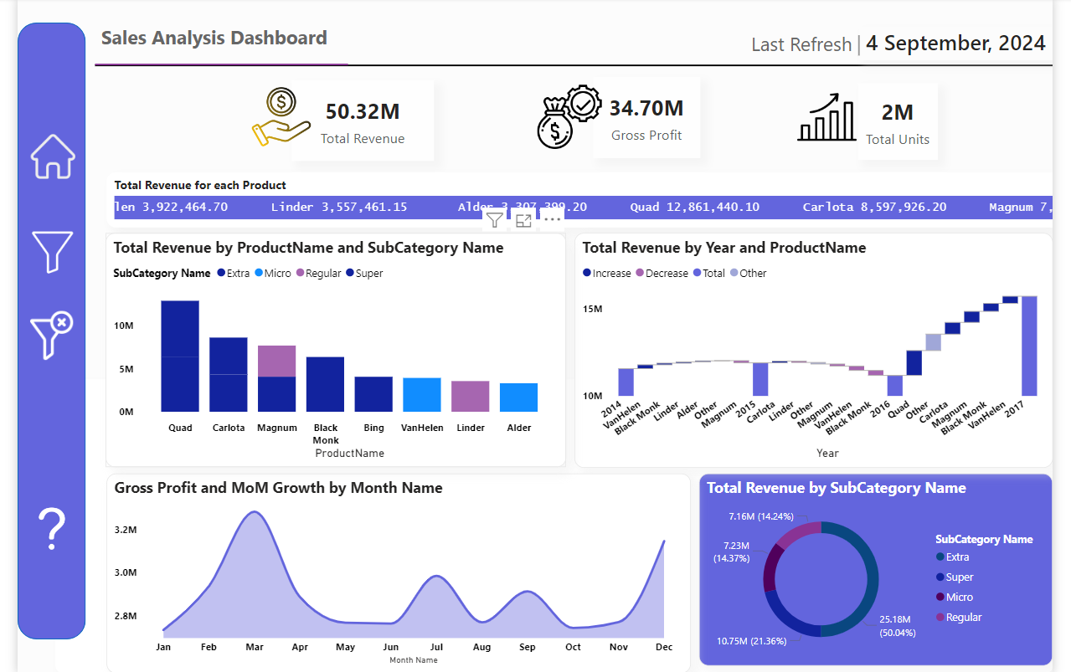

850 | Height
1400 | Width
#272E48 | Page Background
#333753 | Filter Panel and border
#333753 | Cards
#2BFF99 | Cards Title
#97C9D6  #0A5A76 | Charts Colors

